DEPI Project
Nasser Tarek Nasser
Hisham Ahmed Abbas
Mostafa Kadry Motawe
Mazen Mohamed Elbadry

[30/11/2025] | 

Project Architecture

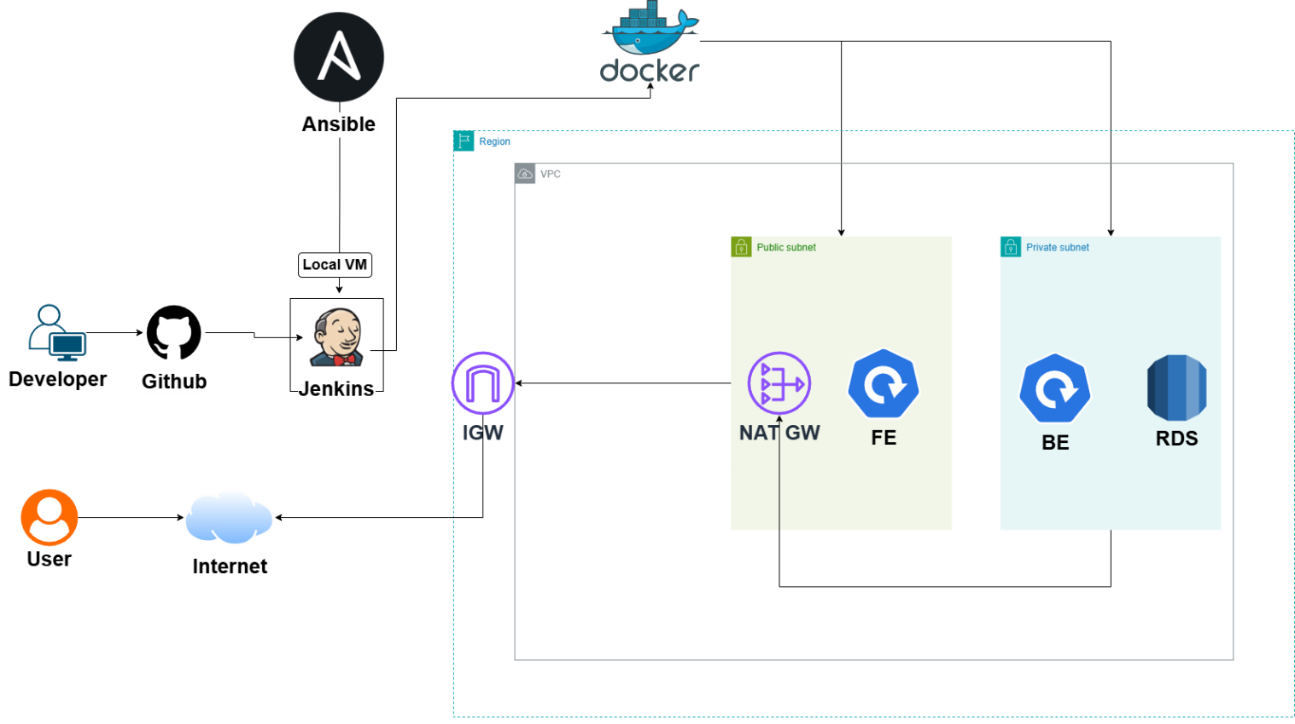
Our application is a three-tier cloud-native system deployed on AWS using:
- Frontend (React)
- Backend API (Node.js + Express)
- Database (AWS RDS – PostgreSQL)
- Containerization using Docker
- Orchestration using Kubernetes (K3s distribution)
- Compute layer: Two EC2 instances
  - One node running K3s Master
  - One node acting as K3s Worker

The architecture is designed to be lightweight, modular, scalable, and suitable for DevOps pipelines, CI/CD, and cloud deployments.


Presentation Tier — Frontend
- Implemented using React.
- Built with Vite for fast bundling.
- Packaged into a static build served via Nginx.
- Containerized using a multi-stage Dockerfile:
  - Stage 1: Build React app
  - Stage 2: Serve with Nginx
- Deployed to the Kubernetes cluster as a Deployment + Service.
- Exposed to the internet using Traefik Ingress (included with K3s).

Responsibilities
- User interface (UI)
- Rendering notes list
- Interacting with backend via REST API
- Creating and deleting notes

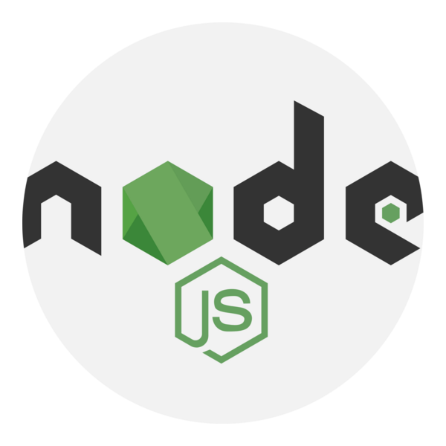
Application Tier — Backend API
- Implemented using Node.js / Express.
- Provides REST API endpoints:
  - GET /api/notes
  - POST /api/notes
  - DELETE /api/notes/:id
- Uses pg package to connect to PostgreSQL.
- Containerized using Docker and deployed as a Kubernetes Deployment.
- Communicates securely with AWS RDS.

Responsibilities
- CRUD operations on notes
- Business logic
- Database communication

Data Tier — Database (AWS RDS)
- Uses Amazon RDS PostgreSQL instead of a local containerized DB.
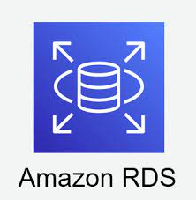
- Ensures:
  - High availability
  - Automated backups
  - Managed scaling
  - Security through AWS IAM + Security Groups

Responsibilities
- Persisting notes
- Managing structured relational data
- Ensuring durability & availability

Containerization using Docker
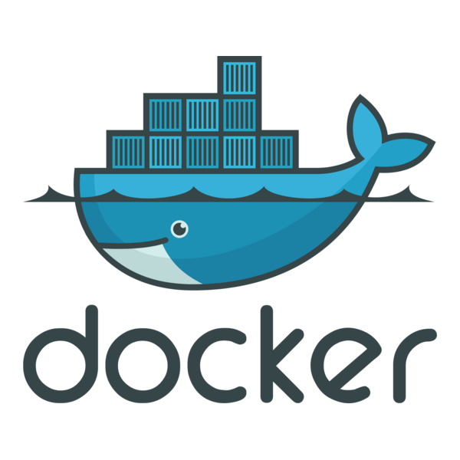
Docker is used to containerize the frontend and backend components of the three-tier application to ensure:
- Consistent runtime environments
- Easy packaging and distribution
- Fast deployment
- Isolation between services
- Simplified local development
Using Docker allows the entire application to run on any machine without manually installing Node.js, Nginx, or any dependencies.

Why Docker?
Docker solves several major problems in software development:
Environment Consistency
The app behaves the same on:
- Your laptop
- A server
- Jenkins
- Kubernetes (later)
There are no OS conflicts, dependency issues, or “works on my machine” bugs.
Isolation
Each service (frontend and backend) runs inside its own container with its own dependencies, avoiding conflicts.

Portability
Once built, a Docker image can run anywhere:
docker run IMAGE_NAME
Lightweight & Fast
Containers start instantly and use fewer resources than virtual machines.

Multi-Stage Build
The frontend uses a multi-stage Dockerfile for optimal performance:

Stage 1 — Build the React App
- Base image: node:18-alpine
- Installs dependencies
- Runs npm run build to generate /dist

Stage 2 — Serve with Nginx
- Base image: nginx:stable-alpine
- Copies the built /dist folder
- Exposes port 80
- Runs Nginx to serve static files

5. Backend Docker Image
Backend Dockerfile
- Base image: node:18-alpine
- Installs backend dependencies
- Copies application code
- Exposes port 5000
- Runs the Express server

6. Database Container (Development Only)
During local development, Postgres is containerized using:
- Official postgres:15 Docker image
- Mounted initialization scripts (init.sql)
- Persistent volume (db_data) to store DB files

Why use Docker for DB locally?
- Instant setup
- Clean environment for every team member
- No need to install Postgres manually
- Matches production schema via SQL scripts

7. Local Development Using Docker Compose

Before deploying anywhere, all services ran together using docker-compose:
docker-compose.yml responsibilities
- Starts frontend, backend, and postgres containers
- Creates an internal network for services
- Handles order of startup (depends_on)
- Exposes ports externally for testing:
  - Frontend → :8080
  - Backend → :5000
  - Postgres → :5432


Jenkins
In this project, Jenkins serves as the automation server responsible for:
- Building Docker images for the frontend and backend
- Authenticating with Docker Hub
- Pushing versioned images to the Docker registry
Jenkins acts as the backbone of our CI pipeline, ensuring consistent and automated builds every time we update the codebase.

Why Jenkins?
Jenkins was selected because it provides:
Automation
Every commit triggers a pipeline that builds and publishes Docker images automatically.
Consistency
Jenkins uses the same Dockerfile every time, guaranteeing reproducible images.
Integration with Docker
Jenkins supports:
- docker build
- docker login
- docker push
right inside pipeline stages.
Ease of use
A simple pipeline definition (Jenkinsfile) controls the entire process.

What Jenkins Does in This Project
Jenkins is responsible for three main tasks:
Checkout Source Code
Jenkins pulls the latest code from the GitHub repository, ensuring that it always builds the newest version of the application.

Build Docker Images
Jenkins builds Docker images for:
- Frontend (React + Nginx)
- Backend (Node.js + Express)

It executes commands such as:
docker build -t depi_frontend:latest ./frontend
docker build -t depi_backend:latest ./backend

These steps ensure:
- Container images are always up-to-date with the latest code.
- Builds are consistent every time because Jenkins uses the Dockerfile.

Authenticate & Push Images to Docker Hub
Jenkins logs into Docker Hub using stored secure credentials:
docker login -u <username> --password-stdin
Then it pushes the images:
docker push depi_frontend:latest
docker push depi_backend:latest
This makes the images publicly (or privately) available for deployments on any environment.

